**Overview**

The purpose of this analysis is to determine whether a charitable organization will donate based on several variables. A neural network was used to make predictions based on all relevant data. The neural network was then optimized to try and increase the accuracy of the predictions.

**Results**

**Data Preprocessing**

* Target Variable
  + IS_SUCCESSFUL
* Feature Variables
  + APPLICATION_TYPE
  + AFFILIATION
  + CLASSIFICATION
  + USE_CASE
  + ORGANIZATION
  + STATUS
  + INCOME_AMT
  + SPECIAL_CONSIDERATIONS
  + ASK_AMT
* Removed Variables
  + EIN
  + NAME

**Compiling, Training, and Evaluating the Model**

* AlphabetSoupCharity (Original)
  + Layers
    - 1 hidden layer with 20 nodes and activation="sigmoid"
    - 1 hidden layer with 20 nodes and activation="relu"
    - Output layer with activation='sigmoid'
  + Epochs
    - 100
  + Explanation
    - Base line number of layers, nodes, and epochs
  + Result
    - Does not meet target model performance

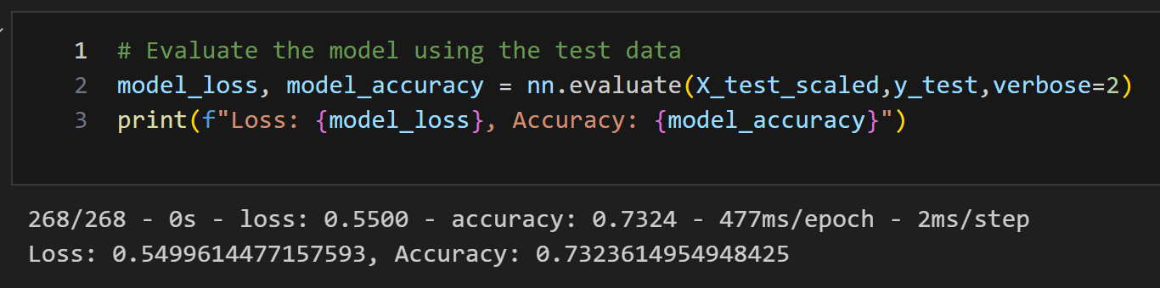

* AlphabetSoupCharity_Optimization_1
  + Layers
    - 1 hidden layer with 50 nodes and activation="sigmoid"
    - 1 hidden layer with 50 nodes and activation="relu"
    - Output layer with activation='sigmoid'
  + Epochs
    - 100
  + Explanation
    - Increased number of nodes to increase accuracy
  + Result
    - Does not meet target model performance

* AlphabetSoupCharity_Optimization_2
  + Layers
    - 1 hidden layer with 50 nodes and activation="sigmoid"
    - 1 hidden layer with 50 nodes and activation="relu"
    - 1 hidden layer with 50 nodes and activation="tanh"
    - Output layer with activation='sigmoid'
  + Epochs
    - 100
  + Explanation
    - Increased number of layers to increase accuracy
    - Added new activation function to test its effect on the performance
  + Result
    - Does not meet target model performance.

* AlphabetSoupCharity_Optimization_3
  + Layers
    - 1 hidden layer with 100 nodes and activation="sigmoid"
    - 1 hidden layer with 100 nodes and activation="relu"
    - 1 hidden layer with 100 nodes and activation="tanh"
    - Output layer with activation='sigmoid'
  + Epochs
    - 150
  + Explanation
    - Increased number of nodes and epochs to give the model more resources and attempts to increase accuracy
  + Result
    - Does not meet target model performance

**Summary**

All the neural networks returned an accuracy around 73%. Adding more hidden layers and nodes made marginal differences in the accuracy of the model but did not surpass the 75% accuracy benchmark. To increase the accuracy of the model I would consider adding more hidden layers and increasing the number of nodes further. I would also try different activation functions in the hidden and output layers. The right combination of changes could increase the accuracy of the predictions.